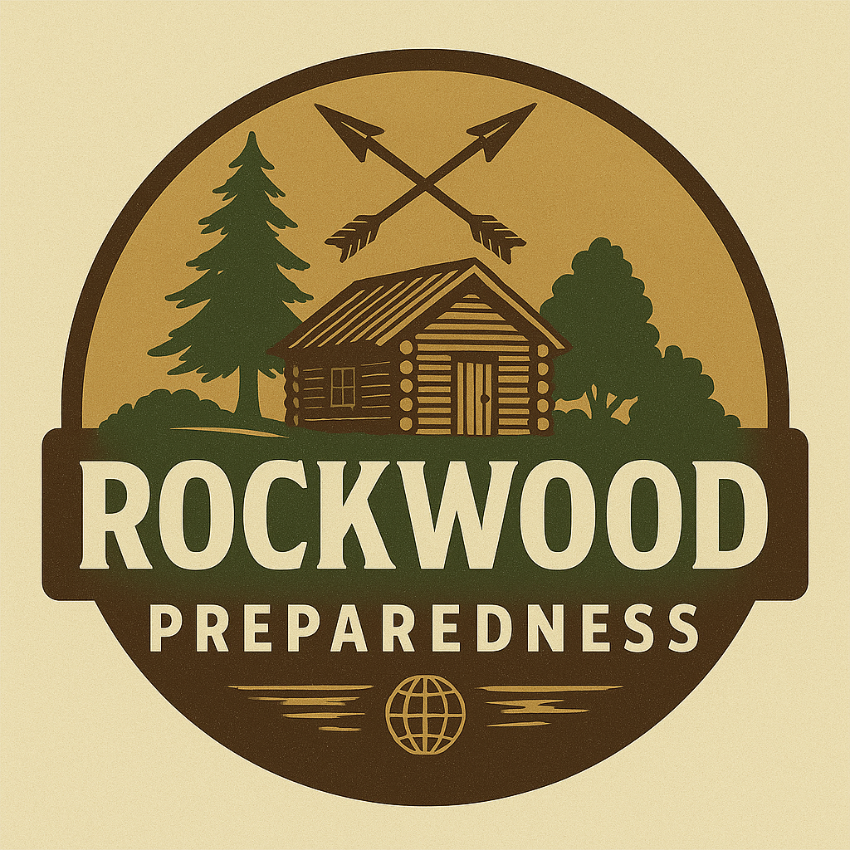

[www.darkpulsebooks.com](http://www.darkpulsebooks.com)

**Instructions:** Research and identify the potential hazards in your area. Mark all that apply to your location.

* + Hurricanes/Tropical Storms
  + Tornadoes
  + Flooding
  + Wildfires
  + Earthquakes
  + Severe Winter Weather
  + Extreme Heat
  + Drought
  + Landslides/Mudslides
  + Tsunamis
  + Volcanic Activity
  + Hazardous Material Incidents
  + Power Outages
  + Public Health Emergencies
  + Civil Unrest
  + Other:

### Resources for hazard information:

* + Local Emergency Management Agency:
  + FEMA Flood Map Service: <https://msc.fema.gov/portal/home>
  + USGS Natural Hazards: <https://www.usgs.gov/natural-hazards>

## HOME VULNERABILITY ASSESSMENT

**Instructions:** Walk through your home and assess its vulnerability to the hazards you identified.

|  |  |  |  |  |
| --- | --- | --- | --- | --- |
| **Area to Assess** | **Potential Vulnerabilities** | **Mitigation Actions** | **Priority (H/M/L)** | **Completed (Date)** |
| Roof |  |  |  |  |
| Windows |  |  |  |  |
| Doors |  |  |  |  |
| Foundation |  |  |  |  |
| Trees/Landscaping |  |  |  |  |
| Utilities |  |  |  |  |
| Drainage |  |  |  |  |
| Fire Hazards |  |  |  |  |
|  |  |  |  |  |
|  |  |  |  |  |
|  |  |  |  |  |
|  |  |  |  |  |